**MySQL Installation and creation of data base table**

**1. Installation resources –**

* 1. [**http://www.mysqltutorial.org/install-mysql/**](http://www.mysqltutorial.org/install-mysql/)
  2. [**https://www.youtube.com/watch?v=WuBcTJnIuzo&t=747s**](https://www.youtube.com/watch?v=WuBcTJnIuzo&t=747s)

**Summary**: this tutorial shows you step by step how to install MySQL on Windows platform using MySQL Installer. After the tutorial, you will have a MySQL database server and its tools up and running in your system for learning and practicing MySQL.

## 2. Download MySQL Installer

If you want to install MySQL on Windows environment, using MySQL installer is the easiest way. MySQL installer provides you with an easy-to-use wizard that helps you to install MySQL with the following components:

* MySQL Server
* All Available Connectors
* MySQL Workbench with Sample Data Models
* MySQL Notifier
* Tools for Excel and Microsoft Visual Studio
* MySQL Sample Databases
* MySQL Documentation

To download MySQL installer, go to the following link <http://dev.mysql.com/downloads/installer/>. There are two files are available. If you are connecting to the internet while installing MySQL, you can choose the online installation version  mysql-installer-web-community.exe . If you want to install MySQL offline, you can download the  mysql-installer-community.exe  file.

## Install MySQL via MySQL Installer

To install MySQL using the MySQL installer, double-click on the MySQL installer file and follow the steps below:

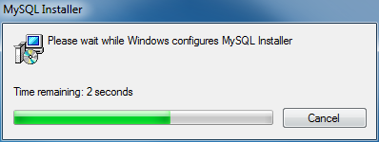  
Install MySQL Step 1: Windows configures MySQL Installer

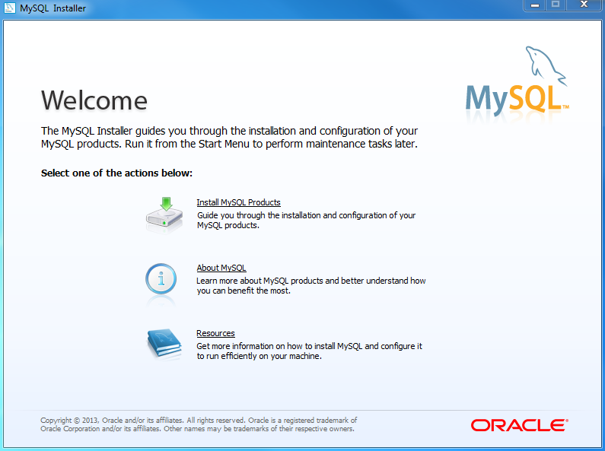  
Install MySQL Step 2 – Welcome Screen: A welcome screen provides several options. Choose the first option: Install MySQL Products

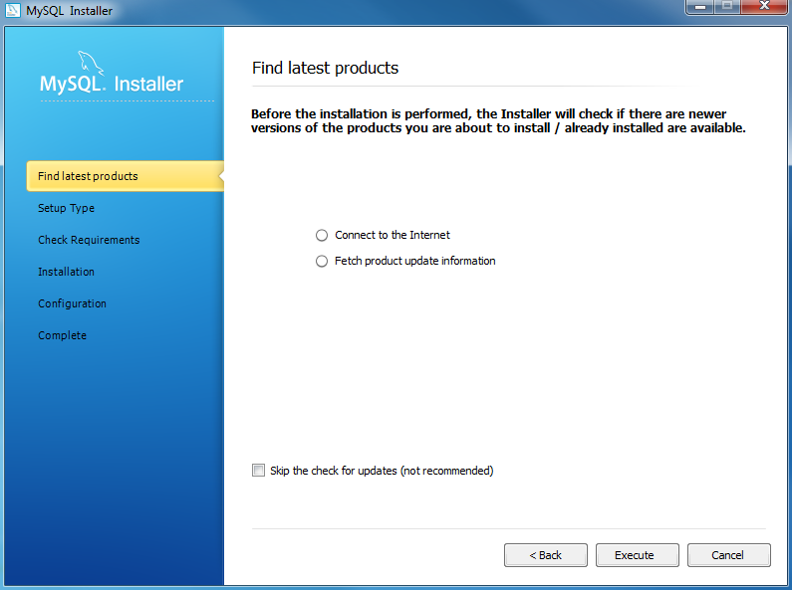  
Install MySQL Step 3 – Download the latest MySQL products: MySQL installer checks and downloads the latest MySQL products including MySQL server, MySQL Workbench, etc.

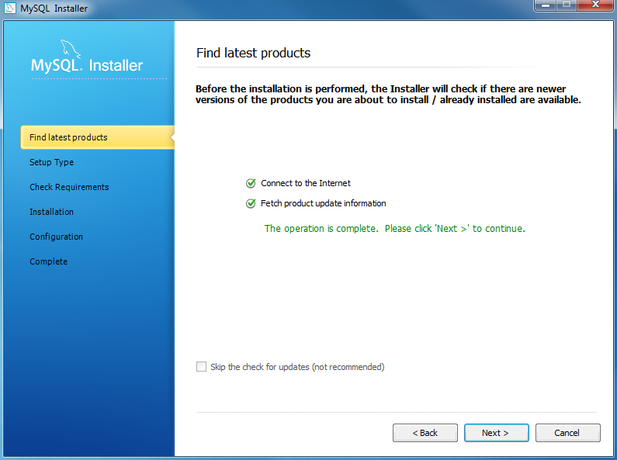  
Install MySQL Step 4: Click Next button to continue

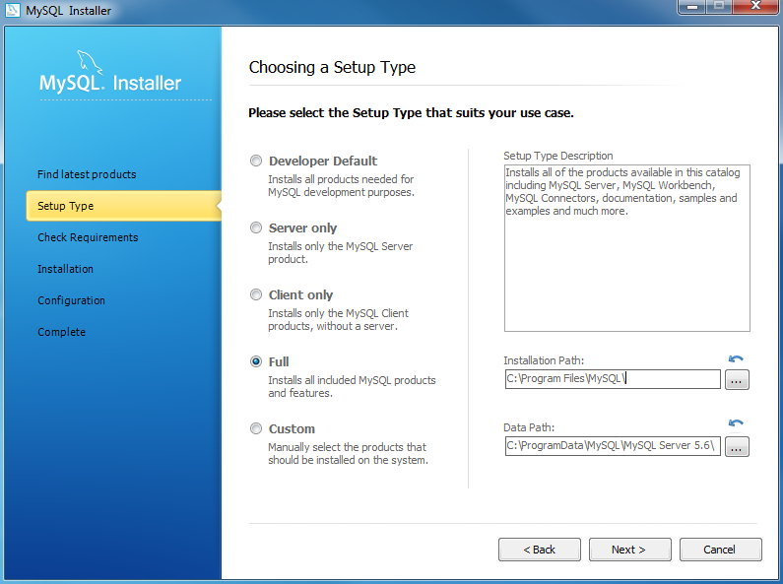  
Install MySQL Step 5 – Choosing a Setup Type: there are several setup types available. Choose the Full option to install all MySQL products and features.

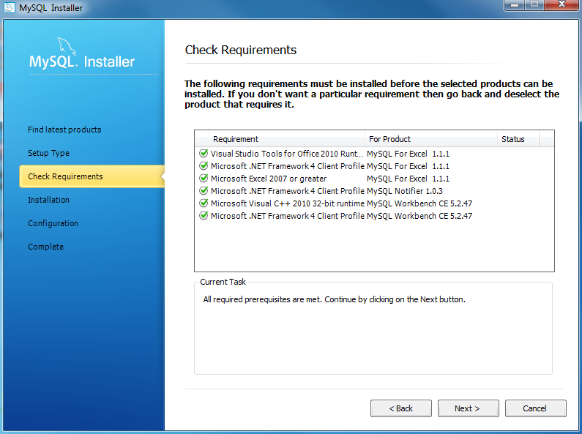  
Install MYSQL Step 6 – Checking Requirements

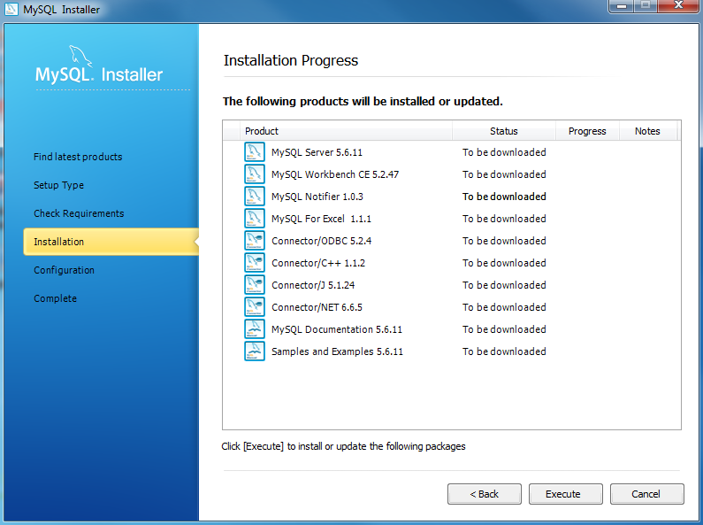  
Install MySQL Step 7 – Installation Progress: MySQL Installer downloads all selected products. It will take a while, depending on which products that you selected and the speed of your internet connection.

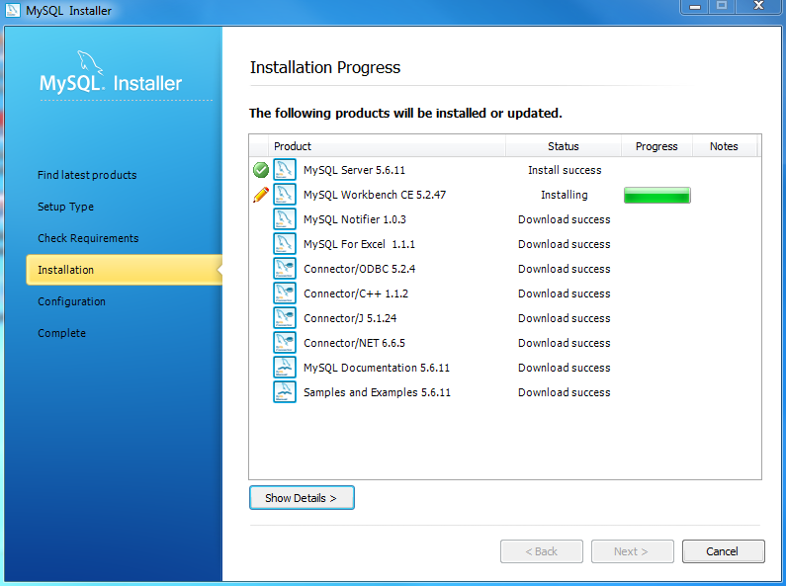  
Install MySQL Step 7 – Installation Progress: downloading Products in progress.

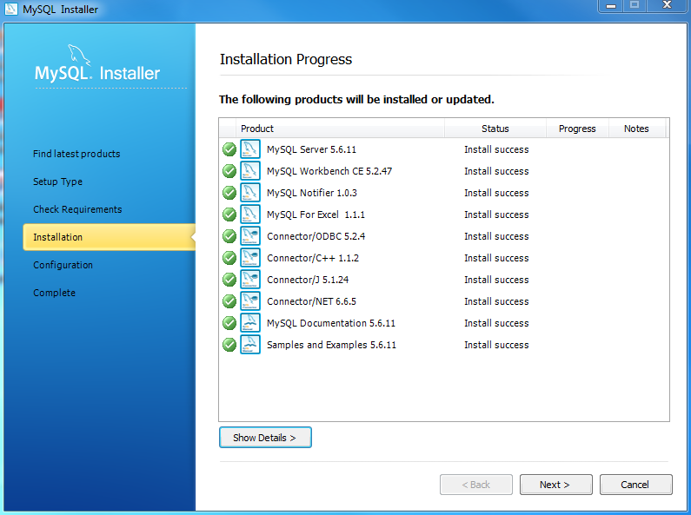  
Install MySQL Step 7 – Installation Progress: Complete Downloading. Click Next button to continue…

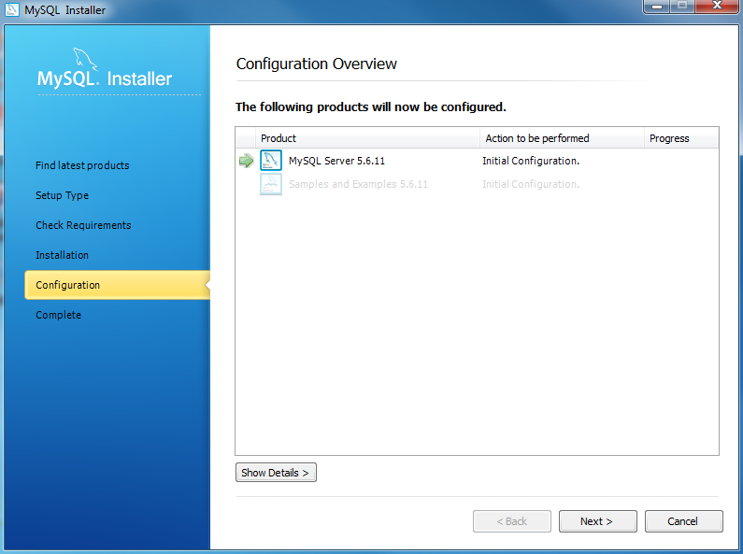  
Install MySQL Step 8 – Configuration Overview. Click Next button to configure MySQL Database Server

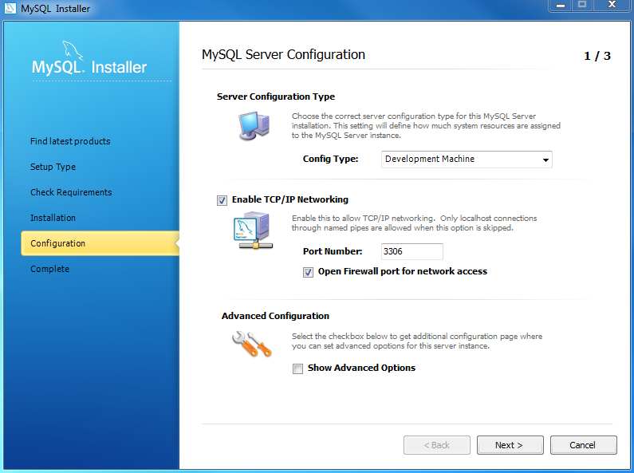  
Install MySQL Step 8.1 – MySQL Server Configuration: choose Config Type and MySQL port (3006 by default) and click Next button to continue.

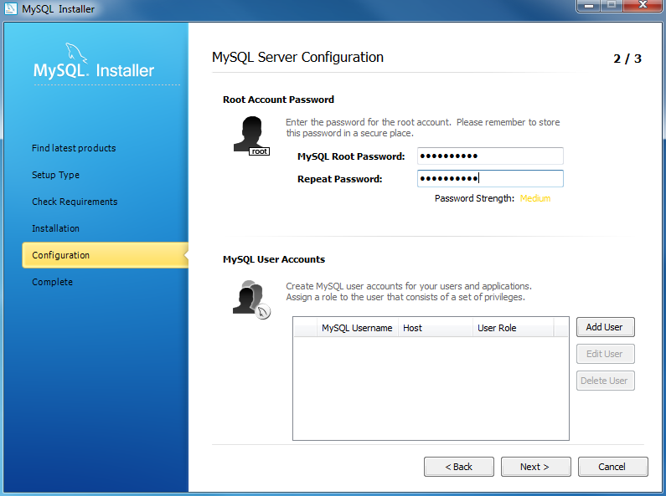  
Install MySQL Step 8.1 – MySQL Server Configuration: choose a password for the root account. Please note the password download and keep it securely if you are installing MySQL database server on a production server. If you want to add a more MySQL user, you can do it in this step.

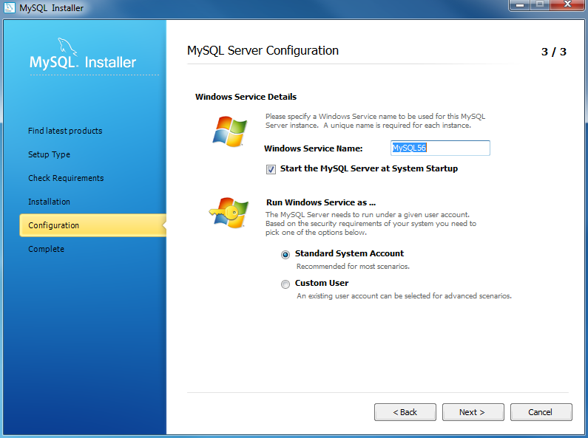  
Install MySQL Step 8.1 – MySQL Server Configuration: choose Windows service details including Windows Service Name and account type, then click Next button to continue.

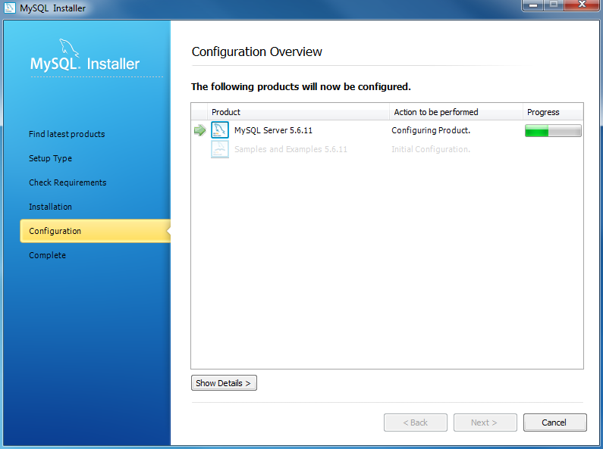  
Install MySQL Step 8.1 – MySQL Server Configuration – In Progress: MySQL Installer is configuring MySQL database server. Wait until it is done and click Next button to continue.

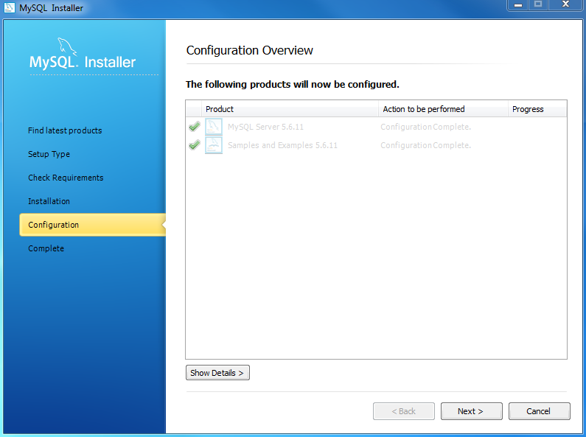  
Install MySQL Step 8.1 – MySQL Server Configuration – Done. Click the Next button to continue.

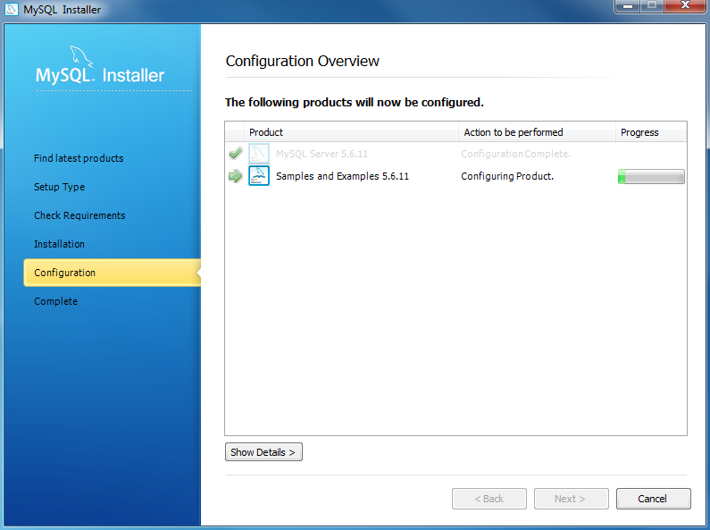  
Install MySQL Step 8.2 – Configuration Overview: MySQL Installer installs sample databases and sample models.

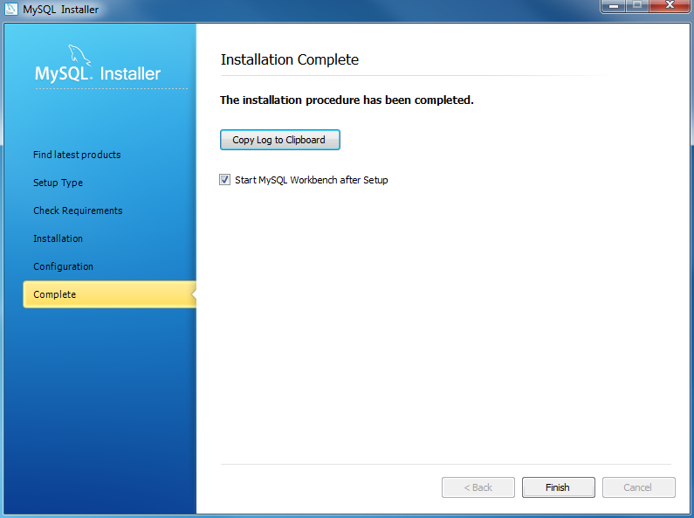

Install MySQL Step 9 – Installation Completes: the installation completes. Click finish button to close the installation wizard and launch the MySQL Workbench.

1. **Follow this below tutorial to create database and table**

<https://www.youtube.com/watch?v=iP1wOSsKjW8&list=PLS1QulWo1RIahlYDqHWZb81qsKgEvPiHn> and

<https://www.youtube.com/watch?v=JyRWDQSQYNw&list=PLS1QulWo1RIahlYDqHWZb81qsKgEvPiHn&index=2>

and create database and table as seen below -

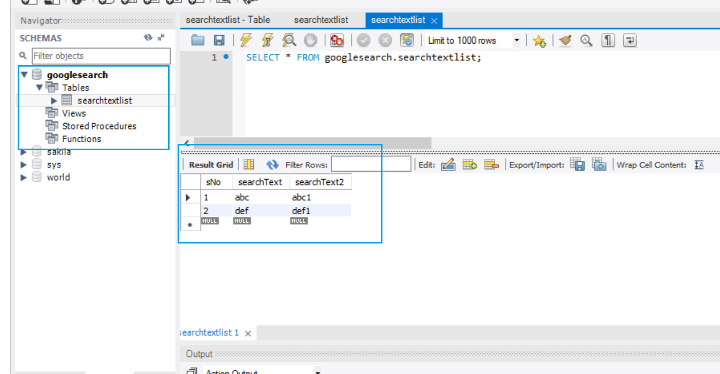

1. **Important trouble shooting Items** 
   1. [MySQL 8.0 - Client does not support authentication protocol requested by server; consider upgrading MySQL client](https://stackoverflow.com/questions/50093144/mysql-8-0-client-does-not-support-authentication-protocol-requested-by-server)

Solution – Enter the following sql statement in MySQL Workbench

ALTER USER root IDENTIFIED WITH mysql_native_password BY 'password';

* 1. **java.sql.SQLException: Unknown initial character set index '255' received from server.**

Solution – Change from 5.1.6 to 5.1.44 fix the issue:

<dependency>

<groupId>mysql</groupId>

<artifactId>mysql-connector-java</artifactId>

<version>5.1.44</version>

</dependency>